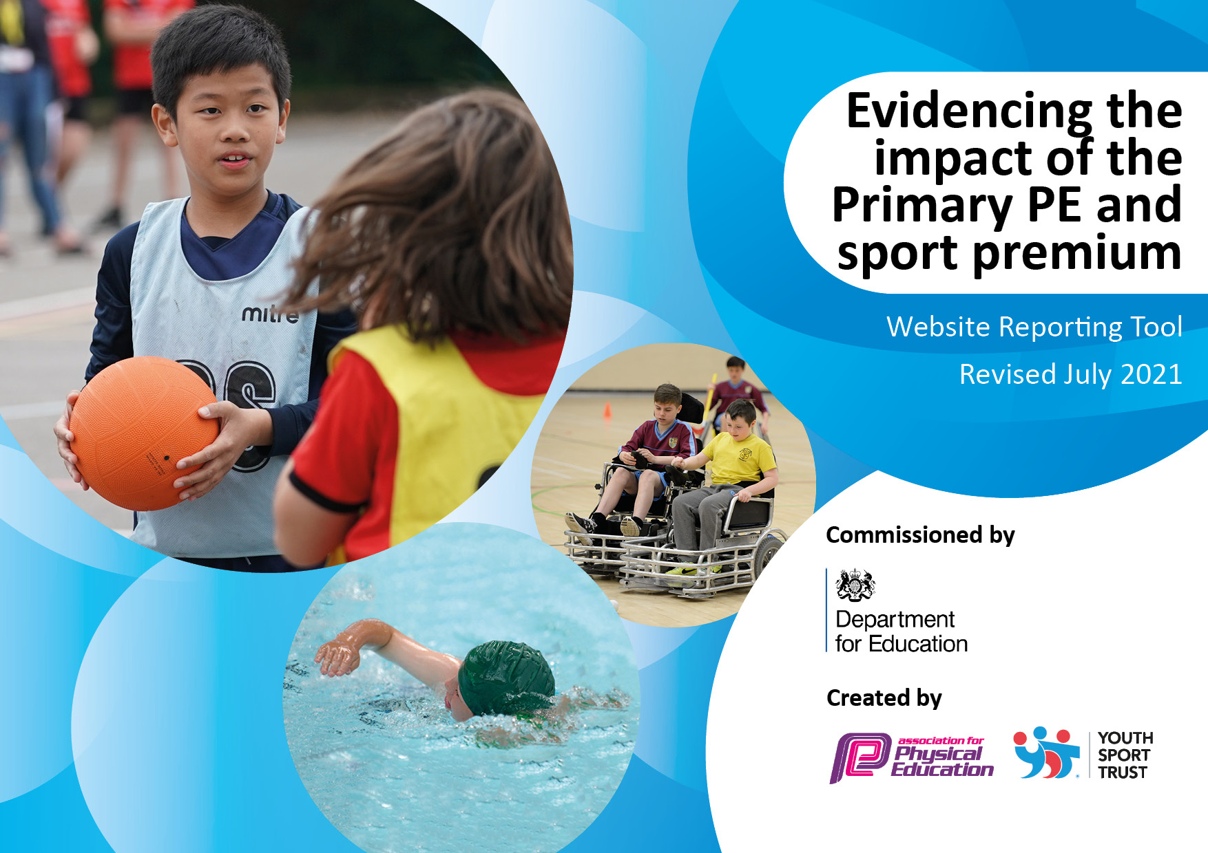
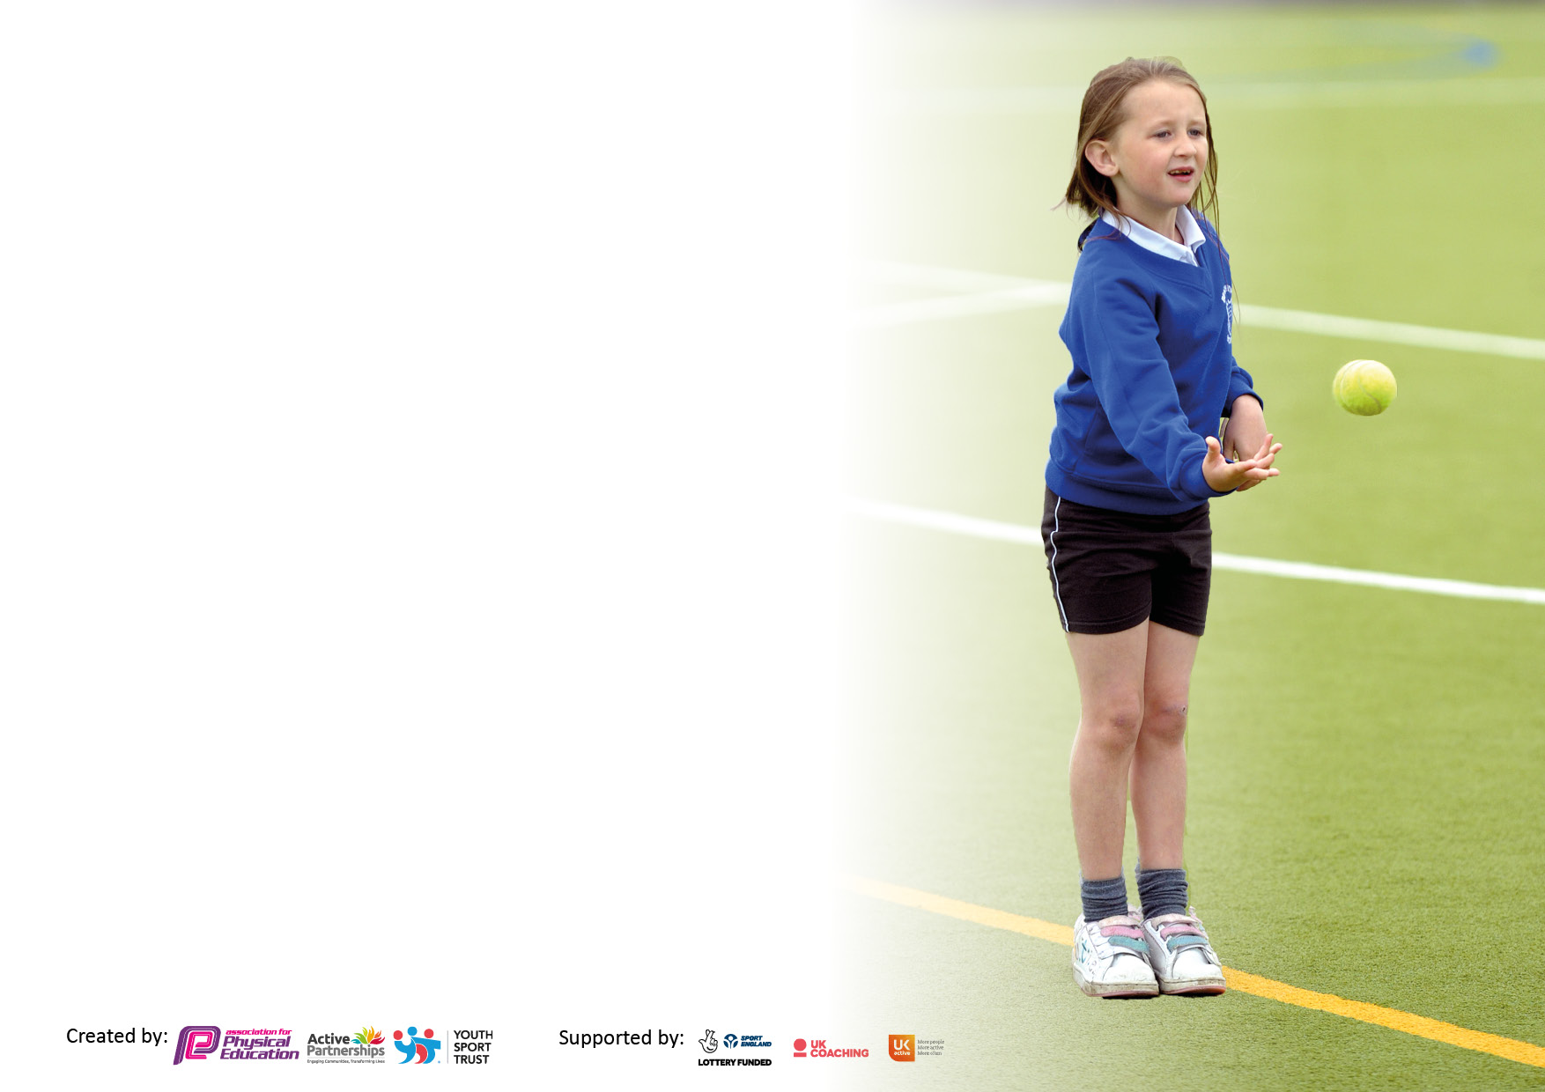

It is important that your grant is used effectively and based on school need. The Education Inspection Framework makes clear there will be a focus on ‘whether leaders and those responsible for governors all understand their respective roles and perform these in a way that enhances the effectiveness of the school’.

Under the Quality of Education Ofsted inspectors consider:
Intent - Curriculum design, coverage and appropriateness
Implementation - Curriculum delivery, Teaching (pedagogy) and Assessment
Impact - Attainment and progress

To assist schools with common transferable language this template has been developed to utilise the same three headings which should make your plans easily transferable between working documents.

Schools must use the funding to make additional and sustainable improvements to the quality of Physical Education, School Sport and Physical Activity (PESSPA) they offer. This means that you should use the Primary PE and sport premium to:

- Develop or add to the PESSPA activities that your school already offer
- Build capacity and capability within the school to ensure that improvements made now will benefit pupils joining the school in future years
- The Primary PE and sport premium should not be used to fund capital spend projects; the school’s budget should fund these.

Please visit gov.uk for the revised DfE guidance including the 5 key indicators across which schools should demonstrate an improvement. This document will help you to review your provision and to report your spend. DfE encourages schools to use this template as an effective way of meeting the reporting requirements of the Primary PE and sport premium.

We recommend you start by reflecting on the impact of current provision and reviewing the previous spend.

Schools are required to publish details of how they spend this funding, including any under-spend from 2019/2020, as well as on the impact it has on pupils’ PE and sport participation and attainment. All funding must be spent by 31st July 2022.

We recommend regularly updating the table and publishing it on your website throughout the year. This evidences your ongoing self-evaluation of how you are using the funding to secure maximum, sustainable impact. Final copy must be posted on your website by the end of the academic year and no later than the 31st July 2021. To see an example of how to complete the table please click HERE.

Details with regard to funding
Please complete the table below.

Total amount carried over from 2019/20 | £5753
Total amount allocated for 2020/21 | £23,673
How much (if any) do you intend to carry over from this total fund into 2021/22? | £7000
Total amount allocated for 2021/22 | £16,730
Total amount of funding for 2021/22. To be spent and reported on by 31st July 2022. | £23,000
Swimming Data - Please report on your Swimming Data below.

Meeting national curriculum requirements for swimming and water safety.  N.B. Complete this section to your best ability. For example you might have practised safe self-rescue techniques on dry land which you can then transfer to the pool when school swimming restarts.  Due to exceptional circumstances priority should be given to ensuring that pupils can perform safe self rescue even if they do not fully meet the first two requirements of the NC programme of study | Swimming took place with the year 5 and 6 class during the summer term 2021.
What percentage of your current Year 6 cohort swim competently, confidently and proficiently over a distance of at least 25 metres?  N.B. Even though your pupils may swim in another year please report on their attainment on leaving primary school at the end of the summer term 2020.  Please see note above | 100%
What percentage of your current Year 6 cohort use a range of strokes effectively [for example, front crawl, backstroke and breaststroke]?  Please see note above | 100%
What percentage of your current Year 6 cohort perform safe self-rescue in different water-based situations? | 100%
Schools can choose to use the Primary PE and sport premium to provide additional provision for swimming but this must be for activity over and above the national curriculum requirements. Have you used it in this way? | The school has mixed year 5/6 classes. Due to this, year 5 pupils undertook swimming lessons during the summer term.

Action Plan and Budget Tracking
Capture your intended annual spend against the 5 key indicators. Clarify the success criteria and evidence of impact that you intend to measure to evaluate for pupils today and for the future.

Academic Year: 2020/21 | Total fund allocated: | Date Updated: July 2021
Key indicator 1: The engagement of all pupils in regular physical activity – Chief Medical Officers guidelines recommend that primary school pupils undertake at least 30 minutes of physical activity a day in school
Intent | Implementation |  | Impact
Your school focus should be clear what you want the pupils to know and be able to do and about  what they need to learn and to  consolidate through practice: | Make sure your actions to achieve are linked to your intentions: | Funding allocated: | Evidence of impact: what do pupils now know and what can they now do? What has changed?: | Sustainability and suggested next steps:
All pupils to undertake physical activity for at least 30 minutes per day.  All pupils to engage in at least two hours of PE each week.  Year 5 and 6 pupils to undertake swimming lessons during the summer term. | All pupils will engage in physical activity every day between 12:30 and 13:00. Activities and equipment to be made available to pupils. Headteacher to be available at lunchtimes during the Autumn term to support pupils and staff on duty.  Rachel Tucker to lead lunchtime tennis sessions once a week during the summer term.  Pupils in Key Stage One and Two to do PE for 2.25 hours per week with children in EYFS undertaking one hour of formal PE followed by a range of physical activities organised in addition to their PE lesson. Headteacher to lead PE sessions during the Autumn and Spring term. This will ensure that all pupils in school during the lockdown get their allocated PE provision. Headteacher to provide online PE activities during the lockdown for those pupils learning from home.  Coach travel arranged for a six week period to enable lessons to take place. TA provided as additional support for class. Teachers to undertake swimming qualification to assist in the delivery of sessions. | £1170  £165  N/A  £700 in 2019/20. To confirm amount for 2020/21. | Pupils engage in physical activity on a daily basis. Staff on duty encourage pupils to be active.  Pupils have access to high quality teaching during lunchtimes.  Pupils are able to progress in terms of the skills and knowledge they learn aligned with the national curriculum requirements.  All pupils acquire key skills even if isolating at home.  100% of pupils in year 5/6 able to swim 25 metres. | To acquire as to what lunchtime clubs can be arranged during the 2021/22 academic year to ensure that all pupils are active at this time.  To ensure that new teachers are confident in the delivery of PE from September.
Key indicator 2: The profile of PESSPA being raised across the school as a tool for whole school improvement

Intent | Implementation |  | Impact
Your school focus should be clear what you want the pupils to know and be able to do and about  what they need to learn and to  consolidate through practice: | Make sure your actions to achieve are linked to your intentions: | Funding allocated: | Evidence of impact: what do pupils now know and what can they now do? What has changed?: | Sustainability and suggested next steps:
To develop and enhance the resources used for the teaching of PE. | School to upgrade and improve resources to enable a higher quality of PE delivery. | £500 | Pupils make improved progress in PE. All pupils actively engaged in PE lessons during the 2020/21 academic year. | The sports facilities across the school still need further development. Headteacher to carry out an audit in 2021/22 and to look at how to improve the outdoor area.
To raise the profile of inter-house sporting competitions. | To purchase stickers and medals for sports day. | £50 | Children will be inspired to do their best and learn new skills and disciplines. | To continue with this into the next academic year.

Key indicator 3: Increased confidence, knowledge and skills of all staff in teaching PE and sport

Intent | Implementation |  | Impact
Your school focus should be clear | Make sure your actions to | Funding | Evidence of impact: what do | Sustainability and suggested
what you want the pupils to know | achieve are linked to your | allocated: | pupils now know and what | next steps:
and be able to do and about | intentions: |  | can they now do? What has
what they need to learn and to |  |  | changed?:
consolidate through practice:
To develop teacher’s skills and confidence in the delivery of PE.  To provide staff with professional development, mentoring, appropriate training and resources to help them teach PE and sport more effectively to all pupils. | Rachel Tucker, tennis coach employed to lead tennis sessions during the Summer term supporting teachers in the delivery of this area.  Sports Activators to lead PE sessions working alongside class teachers in the delivery of fitness based PE sessions aligned with COVID health and safety measures.  Primary PE Planning purchased to provide teachers with planning resources.  Teachers to undertake swimming qualification to lead groups of pupils during swimming sessions.  Stuart Wells to lead PE sessions during the summer term to upskill staff in the delivery of PE lessons.  Most of these sessions will involve upskilling teaching assistants in supporting groups of pupils. | £509  £2418  (NOSSP Partnership)  £395  £183 x 2  £2450 | Teachers are more confident in delivery of tennis lessons. Pupils have enhanced their ball skills and hand to eye co-ordination.  Children were able to maintain physical stamina and fitness upon the return from lockdown.  Teachers taught a range of skills and activities to promote and develop pupil fitness.  Primary PE Planning provides teachers with a range of lesson plans and resources to develop the quality of PE delivery.  Two teachers now confident in the delivery of swimming sessions.  Teachers more confident in the delivery of ball skills and games. Teachers more confident in teaching using a clear structure and providing opportunities for progression. | Rachel to be employed in 2021/22 to deliver lessons working alongside all teachers.  To implement fitness development into PE planning from September 2021.  Head of PE to carry out more lesson observations and monitoring during the 2021/22 academic year.  To train up two teaching assistants to support teachers in the delivery of these sessions in the new academic year.  Headteacher to monitor and observe teachers in 2021/22 to ascertain whether the same quality of lessons is taking place.
Key indicator 4: Broader experience of a range of sports and activities offered to all pupils

Intent | Implementation |  | Impact
Your school focus should be clear | Make sure your actions to | Funding | Evidence of impact: what do | Sustainability and suggested
what you want the pupils to know | achieve are linked to your | allocated: | pupils now know and what | next steps:
and be able to do and about | intentions: |  | can they now do? What has
what they need to learn and to |  |  | changed?:
consolidate through practice:
To promote and develop pupil’s mental health and well-being. | Sports Activators to deliver mental health workshop to year 5 and 6 pupils once a week upon their return to school in the Spring term. | £2418  (NOSSP as above) | Year 5 and 6 pupils provided with a range of strategies to enhance and develop their mental health. | Mental health to be a top priority and focus from September 2021.
To raise the profile of sports and fitness getting more pupils keen on PE. | School to provide more and broaden the variety of extra-curricular activities after school in the 3 to 6pm window.  New clubs to be introduced will include yoga, cricket and rounders. | N/A | Children have the opportunity to engage in a wider range of extra-curricular activities.  After school club now offers a wider range of activities for the pupils. Numbers have not increased substantially although this is mainly due to COVID. | To encourage staff to continue to lead clubs after school in 2021-22.

Key indicator 5: Increased participation in competitive sport

Intent | Implementation |  | Impact
Your school focus should be clear | Make sure your actions to | Funding | Evidence of impact: what do | Sustainability and suggested
what you want the pupils to know | achieve are linked to your | allocated: | pupils now know and what | next steps:
and be able to do and about | intentions: |  | can they now do? What has
what they need to learn and to |  |  | changed?:
consolidate through practice:
To engage in competitive sport to develop pupil’s confidence and skill in match situations. | Suzanne Kirkwood to lead inter-house and inter-class competitions at Charlton in light of COVID pandemic.  SW Sports to organise Sports Day with pupils competing against one another. To up-skill staff in leading inter-house competitions. | £2418 (NOSSP as above)  £300 | All classes competed in competitive indoors volleyball. Pupils able to apply skills learnt to a match scenario.  Pupils took part in a new style sports day where all pupils were involved at all times. Staff developed their practice through learning and working alongside Stuart. | To arrange a lot more inter-school competitions in 2021-22 once COVID restrictions have reduced.  To plan sports day in 2022 using skills learnt from Stuart in 2021.

Signed off by
Head Teacher:
Date: | 31.07.2021
Subject Leader: | Ross Griffin (Headteacher)
Date: | 31.07.2021

